Scala programming

LAB ASSIGNMENT

Name – chaithanya gowda l

USN – 22BTRAD010

Write a Scala program that creates a class BankAccount with properties accountNumber and balance. Implement methods to deposit and withdraw money from the account.

ALGORITHM:

1. **Define the BankAccount class**:
   * Create a class named **BankAccount** with parameters for **accountNumber** (String) and **balance** (Double).
2. **Constructor**:
   * Define a constructor for the **BankAccount** class that initializes **accountNumber** and **balance**.
3. **Deposit Method**:
   * Create a method named **deposit** that takes an **amount** (Double) as a parameter.
   * Add the **amount** to the current **balance**.
   * Print a message indicating the deposit and the new balance.
4. **Withdraw Method**:
   * Create a method named **withdraw** that takes an **amount** (Double) as a parameter.
   * Check if the **amount** is less than or equal to the current **balance**.
     + If true, subtract the **amount** from the current **balance**.
     + Print a message indicating the withdrawal and the new balance.
     + If false, print a message indicating insufficient balance.
5. **Define BankAccountApp object**:
   * Create an object named **BankAccountApp**.
6. **Main Method**:
   * Define a **main** method that takes an array of strings as parameters (**args: Array[String]**).
   * Create an instance of the **BankAccount** class with an account number and an initial balance.
   * Print the account number and initial balance.
   * Deposit an amount into the account using the **deposit** method.
   * Withdraw an amount from the account using the **withdraw** method, considering both sufficient and insufficient balance cases.
7. **Execution**:
   * When the program is run, it will execute the **main** method in the **BankAccountApp** object.
   * The program will display the account number, initial balance, deposit message, and withdrawal messages based on the specified amounts.

INPUT:

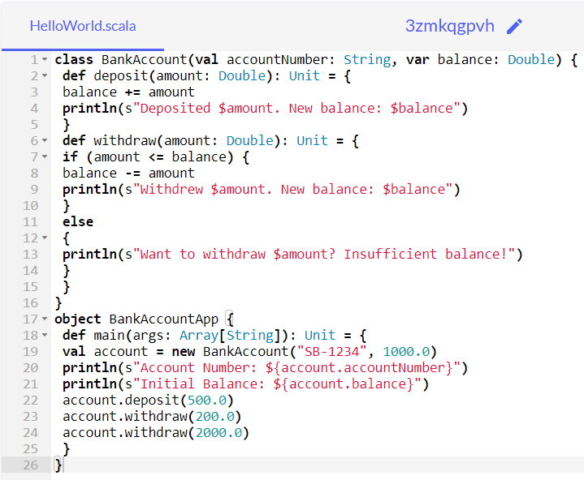

OUTPUT:

